**Introduction**

* 1. **Introduction**

Aquariums have long been revered as captivating microcosms of aquatic life, offering enthusiasts an enchanting window into the mesmerizing world beneath the water's surface. These aquatic habitats teem with life, showcasing a diverse array of colorful fish, vibrant plant life, and intricate ecosystems. However, while aquariums offer unparalleled beauty and fascination, the maintenance and care of these delicate environments present a myriad of challenges.

The intricate balance of water chemistry, temperature regulation, and nutrient management required to sustain aquatic life necessitates meticulous attention to detail and consistent monitoring of environmental parameters. Traditionally, aquarium management has relied heavily on manual intervention and oversight, a process fraught with challenges and limitations. The human error, inconsistency, and time-consuming nature of manual maintenance tasks often result in suboptimal conditions for aquatic inhabitants, compromising their health and well-being.

To address these inherent challenges and limitations, the Smart Aquarium Management System emerges as a pioneering solution, harnessing the power of advanced automation and remote monitoring technologies to revolutionize the maintenance and care of aquarium ecosystems. By seamlessly integrating cutting-edge hardware components and software systems, the Smart Aquarium Management System offers enthusiasts an innovative and comprehensive solution to streamline and enhance aquarium management practices.

* 1. **Objective:**

The Smart Aquarium Management System is designed with the overarching objective of revolutionizing the maintenance and care of aquarium ecosystems by integrating advanced automation, real-time monitoring, and remote accessibility. Through meticulous design, development, and deployment, the system aims to achieve the following key objectives:

1. **Automation of Feeding:**

The first objective of the Smart Aquarium Management System is to develop a sophisticated feeding mechanism that automates the delivery of food to aquatic inhabitants. This entails designing

and implementing a precise feeding system capable of dispensing controlled portions of food at scheduled intervals. By automating the feeding process, the system aims to ensure consistent and controlled nutrition for aquatic inhabitants, thereby reducing reliance on manual feeding schedules and mitigating the risk of overfeeding or underfeeding.

1. **Real-time Monitoring of Water Quality:**

The second objective focuses on integrating a comprehensive suite of sensors to enable real-time monitoring of crucial water parameters. These sensors will continuously measure key metrics such as temperature, pH levels, dissolved oxygen, ammonia levels, and turbidity. By providing real-time data on water quality, the system aims to facilitate precise assessment and management of environmental conditions within the aquarium. This proactive approach to monitoring helps minimize fluctuations in water parameters and ensures the maintenance of optimal water quality, thereby promoting the health and well-being of aquatic inhabitants.

1. **Automated Water Management:**

The third objective is to implement a robust system for automated water management, encompassing monitoring and regulation of water levels, temperature, and filtration processes. Automated water changes will be triggered by predefined thresholds of water quality parameters, such as turbidity levels exceeding acceptable limits. This automated approach to water management ensures the maintenance of pristine water conditions within the aquarium, promoting a healthy and stable aquatic environment for fish and other aquatic life. Additionally, the system will regulate water temperature and filtration processes to further optimize water quality and clarity.

1. **Remote Monitoring and Control:**

The fourth objective revolves around the development of a user-friendly interface for remote monitoring and control of the aquarium system. Enthusiasts will be able to access and manage aquarium operations from any location via a web-based or mobile application. This remote accessibility empowers users to monitor water parameters, adjust settings, and receive alerts or notifications in real-time. By providing convenient remote access to the aquarium system, the Smart Aquarium Management System enhances convenience and peace of mind for enthusiasts, enabling them to stay connected with their aquariums and respond promptly to any changes or emergencies.

* 1. **Overview of the Project**

The Smart Aquarium Management System epitomizes a culmination of innovation and meticulous engineering, endeavoring to tackle the multifaceted challenges inherent in aquarium management. Rooted in a robust foundation of hardware and software integration, the system is meticulously crafted to cater to the diverse needs of aquarium enthusiasts, offering a comprehensive solution to streamline maintenance tasks and optimize environmental conditions.

1. **Hardware Integration:**

At the heart of the Smart Aquarium Management System lies a sophisticated amalgamation of hardware components, meticulously selected and integrated to ensure seamless functionality and performance. The system incorporates an array of essential components, including:

1. **Servo Motors:** These precision-controlled motors serve as the backbone of the system's feeding mechanism, ensuring accurate and consistent delivery of food to aquatic inhabitants.
2. **Sensors:** A diverse suite of sensors, including Temperature sensors, Turbidity sensors, Ultrasonic sensor are strategically deployed throughout the aquarium to provide real-time monitoring of key water parameters. These sensors serve as the system's eyes and ears, continuously collecting data essential for maintaining optimal environmental conditions.
3. **Arduino Microcontrollers:** The brain of the system, Arduino microcontrollers, serve as the central control unit, orchestrating the operation of various components and processing data collected by sensors. Through precise programming and logic, Arduino boards enable intelligent decision-making and automation of maintenance tasks.
4. **Relay Modules:** These modules facilitate the control of external devices such as water pumps, enabling the system to execute automated water changes, temperature regulation with precision and efficiency.
5. **Software Integration:**

Complementing the advanced hardware infrastructure of the Smart Aquarium Management System is a sophisticated software ecosystem meticulously designed to amplify user interaction and system functionality. This integration seamlessly combines Python-based Graphical User Interface (GUI) development with the Arduino Integrated Development Environment (IDE) and the Python modules pyserial and pyfirmata to facilitate seamless communication between the hardware components and the user interface.

**1) Python GUI Development:**

The user-friendly GUI development is at the core of integrating software in the Smart Aquarium Management System. Python, known for its versatility and wide usage, forms the basis for GUI development due to its reliability, ease of use, and rich library support. Developers leverage Python's Tkinter library to craft an intuitive and visually pleasing interface, enabling users to interact effortlessly with the system.

The GUI is designed to be accessible across various devices, including computers, smartphones, and tablets, ensuring convenience and flexibility for users. Through the GUI, users can monitor crucial aquarium parameters such as temperature, pH levels, dissolved oxygen, ammonia levels, and turbidity in real-time. Additionally, users have the ability to customize system settings such as feeding schedules, water change frequencies, and temperature thresholds according to their preferences.

**2) Integration with Arduino IDE:**

The GUI seamlessly integrates with the Arduino IDE, the official software development environment for Arduino microcontrollers. This integration enables bidirectional communication between the GUI and the Arduino board via Python modules pyserial and pyfirmata, facilitating smooth interaction between the software interface and hardware components.

Utilizing pyserial, a Python module for serial communication, the GUI establishes a serial connection with the Arduino board, enabling real-time data transmission and command execution. Pyfirmata, another Python module tailored for Arduino integration, simplifies the communication protocol by providing a high-level interface for interfacing with Arduino pins and components.

1. **Functionality and Operation:**

The Smart Aquarium Management System's functionality spans a wide spectrum of tasks essential for maintaining optimal aquarium conditions. The system's operation can be delineated into several key functionalities:

* 1. **Automated Feeding Mechanism:** Servo motors, controlled by Arduino microcontrollers, execute precise and consistent feeding schedules, ensuring aquatic inhabitants receive adequate nutrition while minimizing the risk of overfeeding or underfeeding.
  2. **Real-time Monitoring of Water Parameters:** Integrated sensors continuously monitor key water parameters, including temperature, pH levels, dissolved oxygen, ammonia levels, and turbidity, providing real-time data to the central control unit. This data serves as the basis for intelligent decision-making and enables proactive management of environmental conditions.
  3. **Automated Water Management:** In response to fluctuations in water quality, the system autonomously initiates water management protocols, including automated water changes, temperature regulation, and filtration processes.

These automated interventions help maintain optimal water quality and environmental conditions within the aquarium, promoting the health and well-being of aquatic inhabitants.

* 1. **Remote Monitoring and Control:** The inclusion of remote monitoring and control capabilities enables enthusiasts to access and manage aquarium operations remotely through the user-friendly GUI. Users can monitor water parameters, adjust settings, and receive alerts or notifications in real-time, enhancing convenience and enabling proactive management of aquarium ecosystems.

**Analysis and Design**

* 1. **Functional Requirement**

Functional requirements outline the specific actions and features that the Smart Aquarium Management System must perform to meet the needs of users effectively. These requirements are essential for ensuring that the system functions as intended and delivers the desired functionalities. Here's a detailed explanation of the functional requirements for the project:

**1. Automated Feeding:**

The Smart Aquarium Management System will incorporate a servo motor to automate the feeding process for aquatic inhabitants. The system will dispense controlled portions of food at scheduled intervals, ensuring consistent nutrition for the fish.

**2. Real-time Monitoring:**

* + - **Ultrasonic Sensor:** The system will utilize an ultrasonic sensor to measure the distance of the water level within the aquarium. This data will provide insights into the water level, facilitating accurate monitoring and management.
    - **Temperature Sensor:** A temperature sensor will be employed to measure the temperature of the water in real-time. This information is crucial for maintaining optimal water conditions for aquatic life.
    - **Turbidity Sensor:** The system will include a turbidity sensor to measure the cloudiness of the water. Monitoring turbidity levels enables the system to assess water clarity and take appropriate actions, such as initiating water changes when necessary.

**3. Automated Water Management:**

* **Water Pump Control:** Two 1-channel relay modules will be utilized to control the operation of water pumps responsible for facilitating water changes

in the aquarium. The system will automate the process of water changes based

on predefined thresholds of turbidity levels, ensuring the maintenance of clean and clear water conditions for aquatic inhabitants.

**4. Remote Access:**

Users will have the ability to remotely monitor and control the aquarium system through a user-friendly interface accessible via computer, smartphone, or tablet. The interface will provide real-time

data on water temperature, water level, and turbidity, allowing users to adjust settings and initiate water changes as needed, even from a remote location.

**5. Alerts and Notifications:**

The system will provide real-time alerts and notifications to users in case of critical changes in water parameters or system malfunctions. These alerts may include notifications about abnormal turbidity levels or water pump malfunctions, enabling users to take prompt action and ensure the well-being of aquatic inhabitants.

By focusing on the mentioned sensors and components, the Smart Aquarium Management System will deliver automated feeding, real-time monitoring, automated water management, remote access, and alerts/notification functionalities tailored to optimize the care and maintenance of the aquarium ecosystem.

* 1. **Non-Functional Requirements**

Non-functional requirements specify the qualities or attributes of the Smart Aquarium Management System that are not directly related to its specific functionalities but are essential for ensuring its overall effectiveness, usability, reliability, performance, and security. Here's a detailed explanation of the non-functional requirements for the project:

1. **Performance:**

* **Scalability:** The system should be designed with scalability in mind to accommodate future integrations with cloud-based services and support increased user access from multiple devices. It should be able to scale seamlessly to handle growing data loads and user interactions without sacrificing performance.
* **Efficient Data Transmission:** When transitioning to cloud-based services, the system should ensure efficient data transmission between the local system and the cloud servers. Data compression techniques and optimized protocols should be employed to minimize bandwidth usage and latency.
* **Optimized Resource Utilization:** The system should utilize system resources efficiently, especially in resource-constrained environments such as edge devices or mobile platforms. Memory and processing resources should be optimized to maximize performance and minimize power consumption.

1. **Reliability:**
   * + **Fault Tolerance:** In the event of network disruptions or cloud service outages, the system should maintain functionality and data integrity by implementing fault-tolerant mechanisms. Data synchronization and backup strategies should be in place to prevent data loss and ensure system reliability.
     + **Redundancy:** Redundant components and failover mechanisms should be implemented to mitigate single points of failure and ensure continuous operation. Critical system components, such as data storage and communication channels, should have backup systems in place to minimize downtime.
2. **Usability:**
   * + **Cross-Platform Compatibility:** The user interface should be compatible with a variety of devices and platforms, including smartphones, tablets, desktops, and web browsers. It should provide a consistent user experience across different devices, allowing users to access and interact with the system seamlessly.
     + **Cloud-Based Interface:** The cloud-based user interface should be intuitive and user-friendly, with features such as drag-and-drop functionality, responsive design, and customizable dashboards. Users

should be able to access and manage aquarium parameters from any device with internet connectivity, enhancing convenience and accessibility.

1. **Security:**
   * + **Data Encryption and Access Control:** Data transmitted between the local system and cloud servers should be encrypted to protect against unauthorized access or interception. Access to sensitive data and system functionalities should be restricted based on user roles and permissions, ensuring data privacy and security.
     + **Secure Authentication:** Cloud-based services should implement secure authentication mechanisms, such as multi-factor authentication or OAuth, to verify the identity of users and prevent unauthorized access to the system.Strong password policies and session management techniques should be enforced to prevent unauthorized access.
2. **Maintainability:**
   * + **Modular Architecture:** The system architecture should be modular and extensible, allowing for easy integration of new features and updates. Changes to system components should be implemented with minimal disruption to existing functionality, facilitating ongoing maintenance and enhancements.
     + **Version Control and Documentation:** Comprehensive documentation should be provided for the system architecture, codebase, and deployment processes. Version control systems, such as Git, should be used to track changes and facilitate collaboration among developers. This documentation will aid in troubleshooting, debugging, and maintaining the system over time.

By considering these non-functional requirements, the Smart Aquarium Management System can effectively transition from its initial implementation to a scalable, reliable, and user-friendly solution that leverages cloud-based services to enhance accessibility, security, and maintainability across various devices and platforms.

* 1. **Architecture:**For the Smart Aquarium Management System, we can design a layered architecture that facilitates seamless communication between the hardware components, local software application, and cloud-based services. Here's an overview of the proposed architecture:

1. **Hardware Layer:**

At the lowest level of the architecture is the hardware layer, consisting of the physical components responsible for monitoring and controlling the aquarium environment. This includes sensors such as the ultrasonic sensor for water level measurement, temperature sensor for temperature monitoring, turbidity sensor for water clarity assessment, and actuators such as servo motors for feeding and relay modules for controlling water pumps.

1. **Local Software Application Layer:**

The local software application layer sits above the hardware layer and serves as the intermediary between the hardware components and the user interface. This layer consists of software modules responsible for data acquisition, processing, and communication with the hardware components. The local application manages the real-time monitoring of aquarium parameters, executes automated tasks such as feeding and water changes based on predefined algorithms, and facilitates communication with the user interface.

1. **Cloud-Based Service Layer:**

The cloud-based service layer resides above the local software application layer and provides additional functionalities such as remote access, data storage, and analytics. This layer leverages cloud-based platforms and services to extend the capabilities of the system beyond the local environment. Cloud services can include databases for storing historical data, APIs for accessing data and functionalities remotely, and analytics tools for generating insights from the collected data.

1. **User Interface Layer:**

At the top of the architecture is the user interface layer, which enables users to interact with the system and access its functionalities. The user interface can be implemented as a web-based dashboard accessible via web browsers on desktop computers, smartphones, or tablets. The interface provides real-time monitoring of aquarium parameters, allows users to adjust settings and schedules, and receives alerts and notifications from the system. It communicates with the local software application layer to send commands and receive updates from the hardware components.

* 1. **Security Design and Considerations:**

Security design and considerations are crucial for ensuring the confidentiality, integrity, and availability of data and functionalities within the Smart Aquarium Management System. Here's an explanation of the security design and considerations for the project:

1. **Authentication and Authorization:**

* **User Authentication:** Implement robust authentication mechanisms to verify the identity of users accessing the system. This may include username/password authentication, multi-factor authentication, or biometric authentication methods.
* **Access Control:** Define granular access control policies to restrict access to sensitive functionalities and data based on user roles and permissions. Ensure that only authorized users have the necessary privileges to perform specific actions within the system.

1. **Data Encryption:**

* **Data Transmission:** Encrypt data transmitted between the user interface, local software application, and cloud-based services to prevent eavesdropping or interception by malicious actors. Use secure communication protocols such as HTTPS/TLS to encrypt data in transit.
* **Data Storage:** Encrypt sensitive data stored in databases or cloud storage to protect against unauthorized access or data breaches. Employ strong encryption algorithms and key management practices to safeguard data at rest.

1. **Secure Communication:**

* **Between Components:** Implement secure communication protocols between hardware components, local software application, and cloud-based services. Use encryption and

authentication mechanisms to ensure the confidentiality and integrity of data exchanged between system components.

* **With External Services:** When integrating with external services or APIs, verify the security measures implemented by third-party providers. Use secure APIs with proper authentication and authorization mechanisms to establish secure communication channels.

1. **Secure Configuration and Management:**

* **Device Configuration:** Ensure that hardware components are securely configured with default passwords changed, unnecessary services disabled, and firmware/software updates applied regularly to patch known vulnerabilities.
* **Access Controls:** Implement access controls and logging mechanisms to monitor and track user activities within the system. Maintain audit logs of user actions, system events, and security-related incidents for compliance and forensic analysis purposes.

1. **User Education and Awareness:**

* **Security Training:** Provide security awareness training to system users and administrators to educate them about common security threats, best practices for password management, phishing awareness, and incident response procedures. Promote a culture of security awareness and vigilance among users to mitigate the risk of social engineering attacks.

1. **Secure Software Development Practices:**

* Follow secure coding practices and guidelines to minimize the risk of common vulnerabilities such as injection attacks, cross-site scripting (XSS), and cross-site request forgery (CSRF).
* Implement input validation, output encoding, and parameterized queries to prevent injection attacks and mitigate the risk of SQL injection and other injection-based vulnerabilities.

**Regular Security Audits and Testing:**

* **Vulnerability Assessments:** Conduct regular security audits and vulnerability assessments to identify potential weaknesses and vulnerabilities in the system. Perform penetration testing to simulate real-world attack scenarios and assess the effectiveness of security controls.

By addressing these security design and considerations, the Smart Aquarium Management System can ensure the protection of sensitive data, prevent unauthorized access or tampering, and maintain the overall security and integrity of the system.

**Implementation**

**3.1 Modules Description**

1. **Data Acquisition Module:**

* **Sensor Data Collection:** This submodule is responsible for collecting data from various sensors installed in the aquarium, including the ultrasonic sensor for water level measurement, temperature sensor for temperature monitoring, and turbidity sensor for water clarity assessment.
* **Data Filtering and Preprocessing:** Once data is collected, this submodule filters out noise and erroneous readings, preprocesses the data to ensure accuracy and consistency, and converts it into a format suitable for further analysis and processing.
* **Data Synchronization:** In systems with multiple sensors distributed across the aquarium, this submodule synchronizes data from different sensors to ensure temporal coherence and alignment for accurate analysis and interpretation.

1. **Control Module:**

* **Actuator Control:** This submodule manages the control and automation of various hardware components in the aquarium, including actuators such as servo motors for feeding and relay modules for controlling water pumps.
* **Control Algorithms:** It executes predefined control algorithms and logic to regulate feeding schedules, initiate water changes based on turbidity thresholds, adjust lighting conditions, and perform other tasks necessary for maintaining optimal environmental conditions within the aquarium.
* **Feedback Mechanisms:** This submodule incorporates feedback mechanisms to monitor the effectiveness of control actions and adjust parameters in real-time based on observed outcomes, ensuring adaptive and responsive control of the aquarium environment.

1. **Communication Module:**

* **Local Communication:** This submodule facilitates communication between the local software application, hardware components, and external systems or services within the local network environment.
* **Remote Communication:** It enables communication with external systems or services, such as cloud-based platforms or mobile applications, allowing remote monitoring and control of the aquarium from any location with internet connectivity.
* **Protocol Translation:** This submodule translates data between different communication protocols and formats used by various components and systems, ensuring interoperability and seamless integration across heterogeneous environments.

1. **User Interface Module:**

* **Web-Based Dashboard:** This submodule provides a user-friendly web-based dashboard accessible via desktop computers, smartphones, or tablets, allowing users to monitor aquarium parameters, adjust settings, and receive alerts and notifications from any location.
* **Interactive Visualization:** It includes interactive visualization tools such as charts, graphs, and gauges to present real-time data in a visually appealing and intuitive manner, enabling users to quickly grasp the current status and trends of the aquarium environment.
* **Responsive Design:** The user interface is designed with responsive design principles to ensure optimal viewing and usability across different devices and screen sizes, providing a consistent user experience regardless of the device used.

1. **Data Processing and Analysis Module:**

* **Statistical Analysis:** This submodule applies statistical techniques and algorithms to analyze sensor data, detect patterns, trends, and anomalies, and derive meaningful insights into the behavior and condition of the aquarium environment.
* **Predictive Modeling:** It utilizes machine learning algorithms and predictive modeling techniques to forecast future trends, predict potential issues or failures, and optimize system parameters for improved performance and efficiency.
* **Rule-Based Reasoning:** This submodule employs rule-based reasoning and expert systems to interpret sensor data, infer actionable insights, and make informed decisions about control actions and system optimizations based on predefined rules and heuristics.

1. **Security Module:**

* **Authentication and Authorization:** This submodule implements robust authentication mechanisms to verify the identity of users and restrict access to sensitive functionalities and data based on user roles and permissions.
* **Data Encryption:** It ensures the confidentiality and integrity of data by encrypting sensitive information transmitted between the user interface, local software application, and cloud-based services, protecting against eavesdropping and tampering.
* **Access Control Policies:** This submodule defines access control policies and enforces security policies to prevent unauthorized access, data breaches, and cyber threats, ensuring compliance with regulatory requirements and industry standards.

1. **Logging and Monitoring Module:**

* Event Logging: This submodule maintains logs of system activities, user interactions, and security-related events, providing an audit trail of system operations for compliance, forensic analysis, and troubleshooting purposes.
* Real-Time Monitoring: It continuously monitors system performance, detects anomalies or irregularities, and generates alerts or notifications to notify users of potential issues or security breaches in real-time, enabling proactive intervention and response.
* Log Analysis and Reporting: This submodule analyzes log data to identify patterns, trends, and anomalies, generates reports and dashboards for visualization and analysis, and provides insights into system behavior and performance over time.

1. **Configuration and Management Module:**

* System Configuration: This submodule allows users to configure system settings, customize control parameters, and set up automated tasks and schedules according to their preferences and requirements.

These detailed modules collectively form the backbone of the Smart Aquarium Management System, enabling it to effectively monitor, control, and optimize the aquarium environment for the health and well-being of aquatic inhabitants.

**3.2 Implementation Details:**

1. **Hardware Setup:**
2. Select and procure the necessary hardware components, including sensors (ultrasonic sensor, temperature sensor, turbidity sensor), actuators (servo motors, relay modules), and microcontrollers (Arduino Uno).
3. Assemble the hardware components according to the system design, ensuring proper wiring connections and physical placement within the aquarium setup.
4. **Sensor Integration:**
5. Connect the sensors to the Arduino Uno microcontroller using appropriate wiring configurations, such as digital or analog pins.
6. Install and configure sensor libraries and drivers within the Arduino IDE to enable communication with the sensors and reading of sensor data.
7. Implement error handling mechanisms to handle sensor failures, data transmission errors, and other potential issues during operation.
8. **Actuator Control:**
9. Connect the actuators (servo motors for feeding, relay modules for water pumps) to the Arduino Uno, ensuring proper wiring and power supply connections.
10. Write firmware code in the Arduino IDE to control the actuators based on input from sensor readings and user commands.
11. Implement safety measures and fail-safe mechanisms to prevent unintended or unsafe operation of actuators, such as limiting servo motor rotation angles or setting maximum run times for water pumps.
12. **Local Software Application:**
13. Develop the local software application using Python programming language, leveraging libraries such as pyserial and pyfirmata for serial communication with the Arduino Uno.
14. Design and implement software modules for data acquisition, processing, analysis, and control logic, ensuring modularity, reusability, and maintainability of the codebase.
15. Implement error handling, logging, and debugging features to facilitate troubleshooting and diagnostics during system operation.
16. **Data Processing and Analysis:**
17. Implement algorithms and logic for processing and analyzing sensor data, including filtering, smoothing, and calibration techniques to ensure accuracy and reliability of measurements.
18. Apply statistical methods, machine learning algorithms, or rule-based reasoning approaches to derive insights, detect patterns, and make informed decisions about system control actions and optimizations.

**3.3 Circuit Diagram**

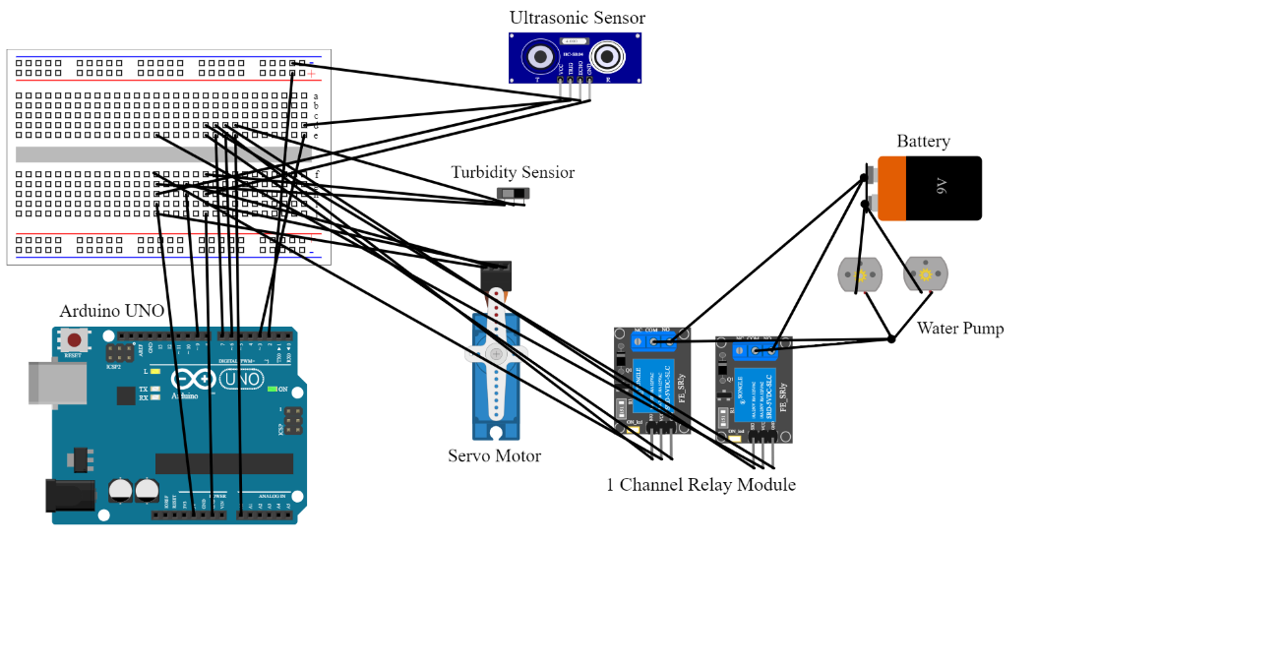



**3.4 Tools Used**

**1. Arduino IDE:**

* **Description:** The Arduino Integrated Development Environment (IDE) is a software platform designed for programming Arduino microcontrollers. It provides a comprehensive set of tools for writing, compiling, and uploading firmware code to Arduino boards.
* **Functionality:** With the Arduino IDE, developers can write code in the Arduino programming language (based on C/C++), compile it into machine-readable binary files, and upload the compiled code to Arduino boards via USB or other communication interfaces.
* **Benefits:** The Arduino IDE features a user-friendly interface, built-in libraries, and examples for interfacing with various sensors, actuators, and peripherals commonly used in embedded systems projects. It supports cross-platform development, making it accessible to developers on Windows, macOS, and Linux.

**2. Python:**

* **Description:** Python is a high-level, interpreted programming language renowned for its simplicity, readability, and versatility. It is widely used in various domains, including web development, data science, automation, and Internet of Things (IoT) applications.
* **Functionality:** Python is used for developing the local software application that interfaces with the Arduino Uno and implements system functionalities such as data acquisition, processing, and control. It offers a rich set of built-in data structures, functions, and libraries for rapid development and prototyping of software applications.
* **Benefits:** Python's simplicity, extensive library support, and cross-platform compatibility make it well-suited for IoT applications. Its ecosystem of libraries includes pyserial and pyfirmata, which are used for serial communication with Arduino microcontrollers and interfacing with hardware peripherals.

**3. Pyserial and Pyfirmata Libraries:**

* **Description:** pyserial and pyfirmata are Python libraries commonly used for serial communication with hardware devices, particularly Arduino microcontrollers, in IoT and embedded systems projects.
* **Functionality:** pyserial enables Python applications to establish serial communication channels with external hardware devices, allowing bidirectional data transfer over serial ports. pyfirmata provides a high-level interface for interacting with Arduino boards and peripherals, abstracting low-level details and simplifying the process of reading sensor data, controlling actuators, and communicating with Arduino pins.
* **Benefits:** These libraries offer simplified APIs and abstraction layers that shield developers from the complexities of serial communication protocols and hardware-specific details. They support a wide range of Arduino boards and configurations, making them versatile tools for interfacing with different Arduino models and hardware setups.

By leveraging these tools effectively, developers can streamline the development process, enhance productivity, and ensure the reliability, security, and maintainability of the Smart Aquarium Management System.

**Testing and Evaluation**

**4.1 Introduction to Testing Procedures**

The testing phase of the Smart Aquarium Management System was a critical component of the development process, ensuring that the system met its functional requirements and performed reliably under various conditions. This phase involved a series of systematic procedures to validate the system's behavior, detect any defects, and optimize its performance.

**Testing Objectives:**

The overarching objectives of the testing phase were multifaceted. Firstly, it aimed to verify that the system accurately met the specified requirements outlined during the design phase. Secondly, it sought to identify and address any defects or inconsistencies in the system's functionality. Additionally, the testing phase aimed to assess the system's overall performance, including responsiveness, accuracy, and reliability, under different usage scenarios.

**Test Plan:**

The test plan served as a comprehensive guide outlining the testing methodologies, techniques, and tools to be employed throughout the testing process. It was meticulously developed to ensure thorough coverage of all aspects of the system's functionality and performance. The test plan encompassed various types of testing, including functional testing to validate individual components, integration testing to verify the interaction between different modules, regression testing to ensure the stability of the system after modifications, and performance testing to evaluate its responsiveness and efficiency.

**Test Cases:**

A detailed set of test cases was meticulously crafted to systematically validate the behavior of the Smart Aquarium Management System across diverse scenarios and conditions. Each test case was designed with specific input data, expected outcomes, and criteria for success, ensuring comprehensive coverage of all system

functionalities and features. These test cases provided a structured approach to testing, allowing for thorough validation and identification of any potential issues.

**Testing Execution:**

The execution of test cases followed a rigorous process outlined in the test plan. Testing environments were carefully set up to replicate real-world conditions accurately. Test scripts were systematically executed, and the system's behavior and performance were meticulously evaluated. Any

issues or discrepancies encountered during testing were promptly addressed and documented to ensure the accuracy and reliability of test results.

**Testing Results:**

The results of the testing phase provided valuable insights into the system's performance and compliance with functional requirements. They highlighted areas of success as well as any defects or anomalies that required attention. Performance metrics such as response times, accuracy rates, and system stability were carefully analyzed to assess the system's overall effectiveness. These results served as a basis for refining and optimizing the Smart Aquarium Management System, ensuring its readiness for deployment and use.

**4.2 Verification:**

1. **Verification Objectives:**

The verification phase of the Smart Aquarium Management System aims to confirm that the implemented system meets the specified requirements and aligns with user expectations. The primary objectives of the verification phase include:

1. **Confirming Correctness:** Ensuring that the system accurately implements the defined requirements without deviation or error.
2. **Validating Completeness:** Verifying that all specified functionalities and features are fully implemented and operational.
3. **Assessing Compliance:** Ensuring adherence to regulatory standards, industry best practices, and any other relevant guidelines.
4. **Verifying Usability:** Assessing the system's usability and user-friendliness, ensuring an intuitive and efficient user experience.
5. **Ensuring Reliability:** Confirming the system's reliability and stability under normal operating conditions.
6. **Verification Procedures:**

The verification procedures encompass a series of systematic activities designed to evaluate the system's conformity to requirements. These procedures include:

1. **Inspection:** Reviewing the system's design documents, codebase, and other artifacts to identify any discrepancies or inconsistencies.
2. **Demonstration:** Conducting demonstrations or walkthroughs of the system to validate its functionalities and features against user requirements.
3. **Testing:** Executing a variety of tests, including functional, integration, regression, and performance testing, to validate the system's behavior under different scenarios.
4. **Review:** Engaging stakeholders, including developers, testers, and end-users, in review sessions to gather feedback and identify areas for improvement.

**4.3 Result**

1. **Fish Feeder Test:**

**Components used:**

1. Servo Motor
2. Jumper wires
3. Arduino UNO

**Test Result:**

The testing results for the servo motor used in fish feeding operations demonstrated robust functionality, high accuracy, and reliable performance. Through rigorous testing, the servo motor consistently dispensed fish food accurately according to programmed schedules, showcasing its precise movement and responsiveness. Additionally, the servo motor exhibited excellent reliability and endurance during prolonged operation, maintaining consistent performance without signs of degradation. Overall, the testing results confirmed the servo motor's suitability for automating fish feeding tasks in the Smart Aquarium Management System, contributing to its efficiency and reliability in maintaining optimal aquatic conditions.

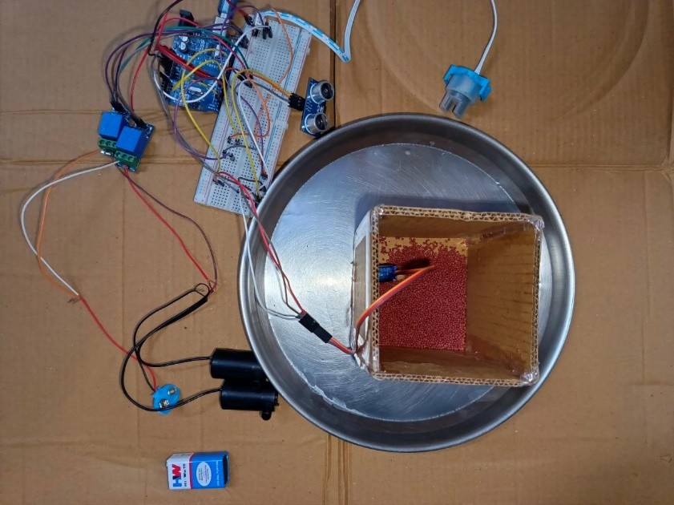**Output:**



1. **Sensor Reading Test:**

**Components used:**

1. Turbidity Sensor
2. Ultrasonic sensor
3. Jumper wires
4. Arduino UNO

**Test Result:**

The testing results for sensor readings from the turbidity sensor and water level sensor, coupled with the calculation of water level percentage using the ultrasonic sensor, yielded valuable insights into water quality and quantity management within the aquarium.

The turbidity sensor provided accurate readings of water cloudiness, allowing for real-time monitoring of water quality. Through rigorous testing, the sensor demonstrated its ability to detect changes in turbidity levels, thus enabling timely interventions such as water filtration or replacement when necessary to maintain optimal water conditions for aquatic life.

Similarly, the water level sensor accurately monitored water levels within the aquarium, facilitating precise management of water quantity. With a tank height of 30 cm and a maximum water capacity of 28 cm, the sensor reliably detected fluctuations in water levels, ensuring that the aquarium remained adequately filled at all times.

Additionally, the ultrasonic sensor played a crucial role in calculating the water level percentage by measuring the distance from the sensor to the water surface. By converting this distance into a percentage relative to the tank height, the ultrasonic sensor provided a precise indication of the current water level, allowing for efficient monitoring and management of water resources.

Overall, the integration of these sensors into the Smart Aquarium Management System proved instrumental in ensuring optimal water quality and quantity, enhancing the health and well-being of aquatic inhabitants while simplifying maintenance tasks for aquarium enthusiasts.

**Output:**

1. **Sensor setup**

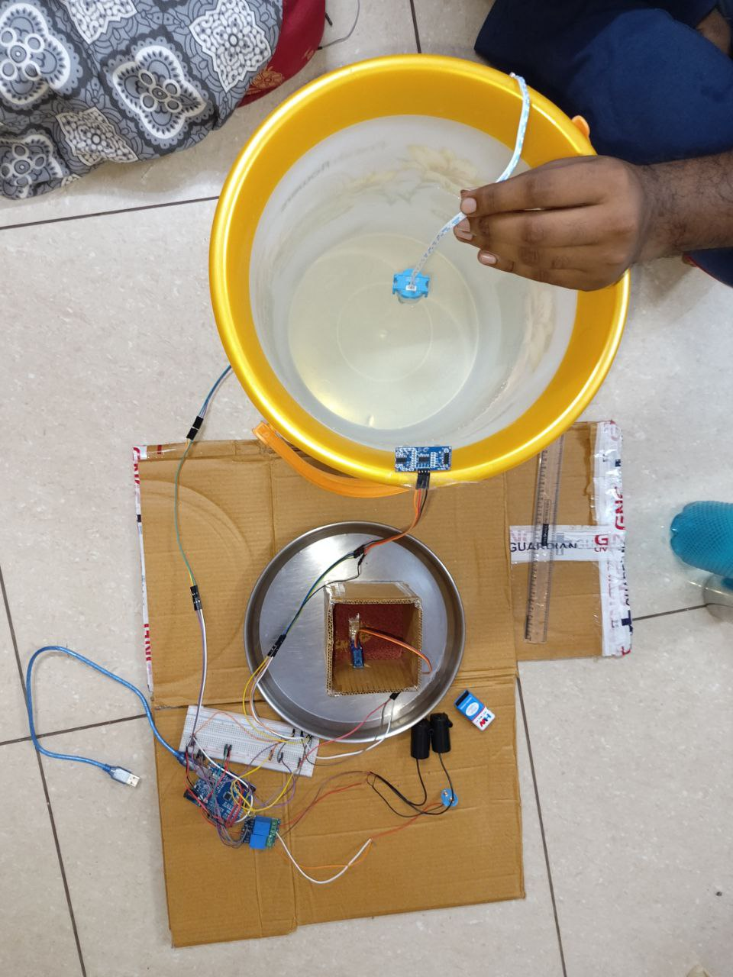



1. **Sensor Initial output:**

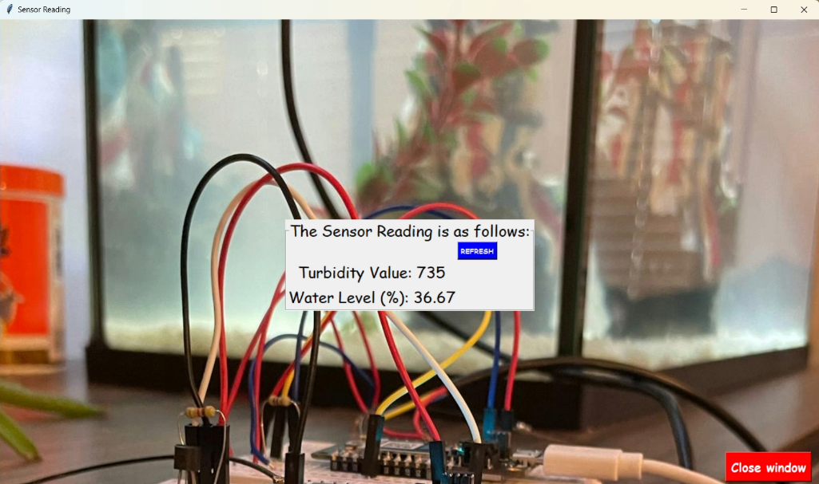



1. **Sensor Final output:**

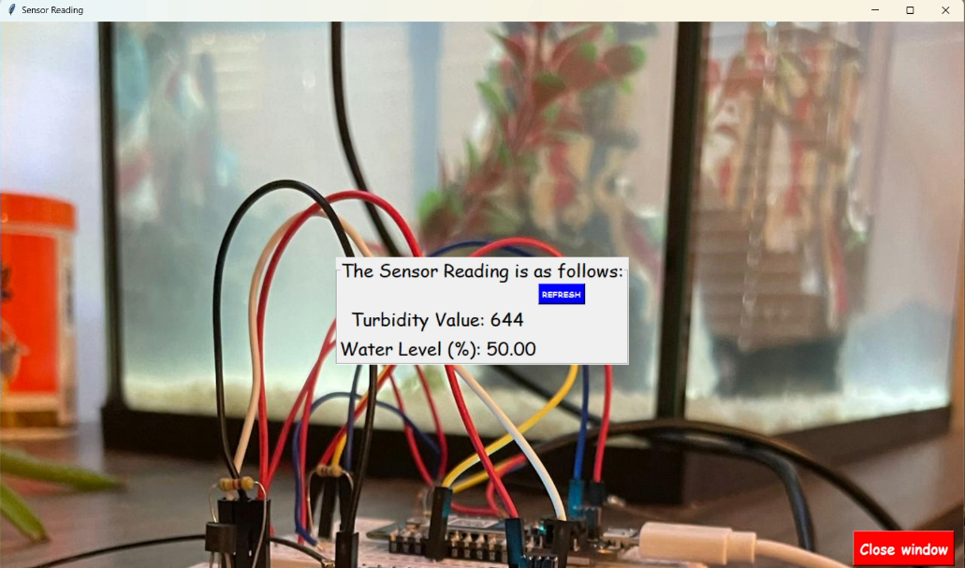



1. **Complete Sensor Connection**

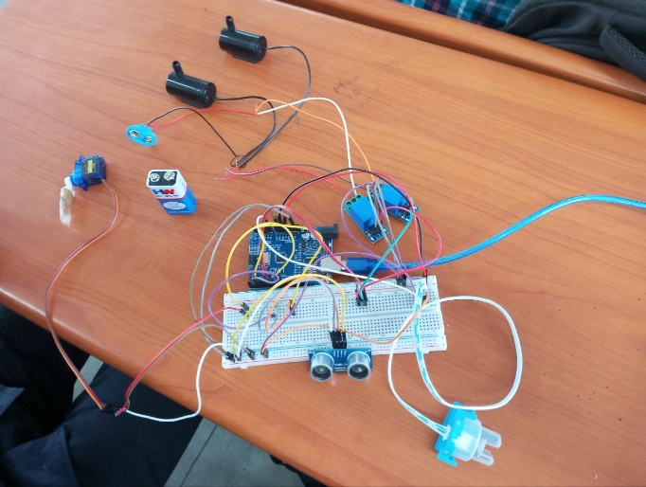



**Conclusions and Further Scope**

**5.1 Future Scope :**

1. **Potential for Integration with Smart Home Ecosystems:**

* **Enhanced Functionality:** Explore synergistic integration with popular smart home platforms like Amazon Alexa or Google Home to unlock new levels of control and convenience for users.
* **Seamless Interaction:** Seamlessly connect the Smart Aquarium Management System with existing smart home ecosystems, allowing users to effortlessly monitor and manage their aquariums using voice commands or intuitive interfaces.

1. **Continuous Improvement and Updates:**

* **User-Centric Development:** Dedicate resources to continuous refinement and enhancement of the system, driven by user feedback and advancements in technology.
* **Stay Ahead of the Curve:** Maintain a proactive approach to updates and improvements, ensuring that the system remains at the forefront of innovation and delivers unparalleled value to users.

1. **Expansion into New Markets and Applications:**

* **Diversification Opportunities:** Identify and capitalize on emerging markets and applications, such as aquaponics or coral reef systems, to cater to a broader range of needs and preferences within the aquarium community.
* **Address Evolving Needs:** Adapt to the evolving landscape of aquarium enthusiasts and professionals by offering versatile solutions that cater to diverse requirements and aspirations.

1. **Enhanced User Experience through Intuitive Interface Design:**

* **User-Centric Interface:** Prioritize user experience by designing an intuitive and user-friendly interface for the Smart Aquarium Management System.
* **Simplified Navigation:** Streamline navigation and interaction to ensure ease of use for users of all levels, from novice aquarium enthusiasts to experienced professionals.

**5.2 Conclusion:**

In conclusion, the development and implementation of the Smart Aquarium Management System represent a significant advancement in the field of aquarium automation and management. Through the integration of innovative hardware components and sophisticated software systems, the system offers a comprehensive solution for monitoring, controlling, and optimizing aquarium environments.

Throughout the project lifecycle, rigorous testing and validation procedures were employed to ensure the system's functionality, reliability, and performance. The successful integration of sensors, actuators, and communication modules enables real-time monitoring of vital parameters such as water quality, temperature, and turbidity, while automated control mechanisms facilitate timely interventions to maintain optimal conditions for aquatic life.

Furthermore, the system's potential for integration with smart home ecosystems opens up new possibilities for enhanced functionality and user convenience. By leveraging voice commands and intuitive interfaces, users can seamlessly interact with the system, empowering them to effortlessly manage their aquariums from anywhere, at any time.

Looking ahead, the commitment to continuous improvement and updates ensures that the Smart Aquarium Management System remains at the forefront of innovation, adapting to evolving user needs and technological advancements. Opportunities for expansion into new markets and applications further solidify its position as a versatile and indispensable tool for aquarium enthusiasts and professionals alike.

In essence, the Smart Aquarium Management System represents a paradigm shift in aquarium maintenance, offering unprecedented levels of automation, control, and convenience. As we embark on this journey of innovation and discovery, we remain committed to enhancing the well-being of aquatic life and empowering users to experience the beauty and wonder of the underwater world like never before.

**Reference**

* + - 1. **David Hanes, Gonzalo Salgueiro, Patrick Grossetete, Rob Barton and Jerome Henry, “IoT Fundamentals: Networking Technologies, Protocols and Use Cases for Internet of Things”**
      2. **William Stallings, “Computer Organization and Architecture: Designing for Performance”, Pearson Education, 11th edition, 2019, ISBN: 978-0-13-499719-3.**
      3. [**https://www.inavateonthenet.net/news/article/ai-aquarium-use-eyetracking-technology-to-be-the-worlds-first-intelligent-aquarium**](https://www.inavateonthenet.net/news/article/ai-aquarium-use-eyetracking-technology-to-be-the-worlds-first-intelligent-aquarium)
      4. [**https://www.inavateonthenet.net/news/article/ai-aquarium-use-eyetracking-technology-to-be-the-worlds-first-intelligent-aquarium**](https://www.inavateonthenet.net/news/article/ai-aquarium-use-eyetracking-technology-to-be-the-worlds-first-intelligent-aquarium)
      5. **Arduino - Home. Retrieved from** [**https://www.arduino.cc/**](https://www.arduino.cc/)
      6. **Python Software Foundation.** [**https://www.python.org/**](https://www.python.org/)
      7. **Tkinter Documentation.** [**https://docs.python.org/3/library/tkinter.html**](https://docs.python.org/3/library/tkinter.html)